|  |
| --- |
| Blood Bank Management System  MUHAMMAD ADNAN ABID(003)  TAJWAR JAVAID (065)  KAINAT GUL (069) |
| C:\Users\abc\AppData\Local\Temp\ksohtml\wps1F99.tmp.png |
|  |
| **June 2019** |
| Department of Computer Science  COMSATS INSTITUTE OF INFORMATION TECHNOLOGY  ATTOCK – PAKISTAN |
|  |

Table of contents

**1 Introduction**

1.1Purpose……………………………………………………. 4

1.2 Problem Statement ………………………………….…… 4

1.3 Scope……………………………………………………... 4

1.4 Existing System……………………………………………6

**2. Requirements and Analysis**

2.1 Module of the Project……………………………………. 6

2.2 Functional Requirements………………………………….6

2.3 Non-Functional Requirements…………………………….7  
  
**3. Design**

3.1 Use Case diagram……………………………..…………..8  
  
 3.2 Class Diagram………………………………………… 11

3.3 Activity Diagram…………………………………………12

3.4 Sequence Diagram………………………………………13

**4. Implementation**

4.1 Login of Admin……………………………………………15

4.2 Admin Page…………………………………………….…18

4.3 Blood Store Page….………………………………………19

4.4 Admin Delete Option………………………………………19

4.5 Login of Donor…………………………………….………20

4.6 Signup of Donor ………………………………….………21

4.7 Donor Data Page……………………….…………………23

4.8 Donor Account Delete…………………………….………23

4.9 Login of Recipient………………………………………...24

4.10 Signup of Recipient………………………………………25

4.11 Recipient Page………………………………………...…27

4.12 Recipient Account Delete…………………………….…27

4.13 Database …………………………………………………28

**1 Introduction:**

The name of our software is “**Blood Bank Management System**”.

**“We are working to save lives”** ~Group Member

Our group decides to make software which helps the society to save their loved ones lives. Blood bank is a place where blood stored that is collected from blood donation.

**General Knowledge about the Domain:**

Let us elaborate our BBMS, this system keeps the record of the entire donor. It also keeps the record of recipients and blood donation program. The tested blood is stored in this system which is pure from all disease. BBMS also maintain the stock. It provides user an online opportunity to check and buy the blood.

1.1 Problem Statement:

The percentage of people donating blood is increasing day by day due to awareness to donate for those who needed. There is no such platform for blood donor so we have to provide a platform where the blood donor and blood receiver are in contact and easily donate and receive blood.

1.3 Scope:

Our scope is limited In Blood Bank Management System because we are just providing a platform for blood donor and blood receiver.

**Customer and Users:**

The users are administration, blood donor and receiver but the customer are only blood donor and receiver.

**The Environment:**

**Client Side**

|  |  |
| --- | --- |
| Processor | 2.4 GHz |
| RAM | 2 GB |
| Hard Disk | 20 GB |
| Operating System | Windows |
| Runtime Environment | .NET Framework 4.5 |
| Web Browser | Internet Explorer |

**Task and procedure currently performed:**

Following task performed in BBMS:

* It allows donor a place where it donates a blood.
* The patient will search their needed blood.
* Most of the blood also available in the system.

Following procedure used in BBMS:

* All the record of blood stored in Database.
* The form will get and store all the data in database.
* BBMS also give location on the blood donation event.

1.4 Existing System:

There is many software in competition but our software is better due to following features:

* User views all Blood Bank information in location wise.
* Donor and patient easily donate the blood near Blood Bank location.

This system also supports inquiry form for user.

**2. Requirements and Analysis**

2.1 Modules:

1. Admin
2. Donor
3. Recipient

2.2 Functional Requirements:

* Login form of Admin.
* Reset admin username and password.
* Registration of blood donor by himself.
* Registration of blood donor by admin.
* Login form of the blood donor.
* Reset username and password of donor.
* Form for blood receiver to see the blood available.
* Sending blood donation detail to the relevant donor.

2.3 Nonfunctional Requirements:

* **Availability:**
* The system should be available at all times, the user can access it using application.
* In case of hardware failure or database corruption a replacement page will be shown. Also in case of hardware failure and database corruption backups of the database should be retrieved from the application data folder and saved by the administrator.
* It means 24 x 7 availability.
* **Reliability:**
* As the system provide the right tools for problem solving it is made in such a way that the system is reliable in its operations and for securing the sensitive details.

**3. Design:**3.1 Use Case:

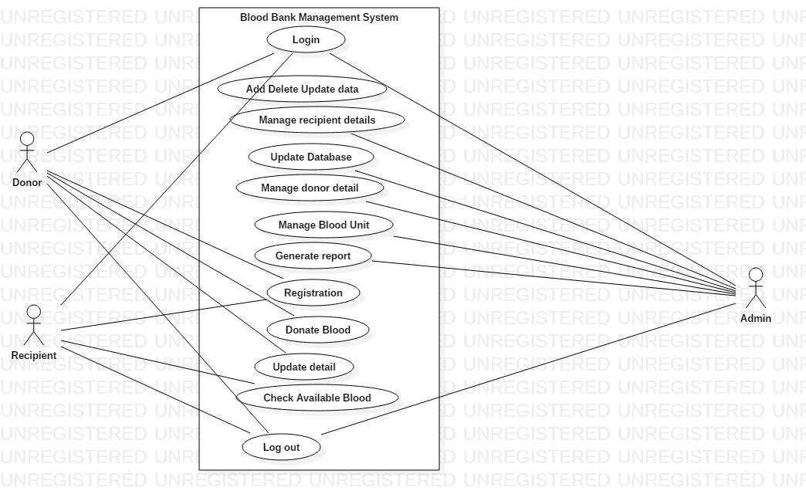

**Use case Description**

Table 1:

|  |  |
| --- | --- |
| **Use Case:** Login | |
| **Actors:** Admin, Donor, Recipient | |
| **Goals:** To allow authorized user to login and prevent others to access system | |
| **Pre-Condition:** You must be registered | |
| **Post- Condition:** Login successfully | |
| **Related Use Cases:** All the use cases are related which are dependent on login use case | |
| **Steps:** | |
| **Actor Action**  1: Provide Information about himself. | **System Responses**  1a. Verification |

|  |  |
| --- | --- |
| **Use Case:** Manage Recipient Record | |
| **Actors:** Admin | |
| **Goals:** To manage all the details of recipients so that they login and deal with system easily | |
| **Pre-Condition:** You must be registered | |
| **Post- Condition:** After first time login you don’t need to give info again and again | |
| **Related Use Cases:** Login, Registration | |
| **Steps:** | |
| **Actor Action**  1: Admin save the detail of all the recipients in database | **System Responses**  1a. System will check that the data is complete and clear and save it |

|  |  |
| --- | --- |
| **Use Case:** Update Database | |
| **Actors:** Admin | |
| **Goals:** To update the already stores detail of donors and recipients | |
| **Pre-Condition:** The detail of donor or recipient already exist before updating | |
| **Post- Condition:** Your personal information update successfully | |
| **Related Use Cases:** Registration, Login, Donor Update Detail | |
| **Steps:** | |
| **Actor Action**  1: Admin update the database when any donor or recipient ask for update | **System Responses**  1a. System database update the info and show update successfully |

|  |  |
| --- | --- |
| **Use Case:** Manage Donor Record | |
| **Actors:** Admin | |
| **Goals:** To manage all the details of donor so that they login and deal with system easily | |
| **Pre-Condition:** You must be registered | |
| **Post- Condition:** After first time login you don’t need to give info again and again | |
| **Related Use Cases:** Login, Registration | |
| **Steps:** | |
| **Actor Action**  1: Admin save the detail of all the recipients in database | **System Responses**  1a. System will check that the data is complete and clear and save it |

|  |  |
| --- | --- |
| **Use Case:** Registration | |
| **Actors:** Donor, Recipient | |
| **Goals:** To interact with the system or to use the system | |
| **Pre-Condition:** The donor or recipient have to give full details about their self | |
| **Post- Condition:** All the information were store in the database of system | |
| **Related Use Cases:** Update donor details, Update recipient details | |
| **Steps:** | |
| **Actor Action**  1: The donor or recipient will fill all the details and save it | **System Responses**  1a. The system database store the detail of donor and recipient |

|  |  |
| --- | --- |
| **Use Case:** Donate Blood | |
| **Actors:** Donor | |
| **Goals:** To insure that the donor will be available to donate blood | |
| **Pre-Condition:** The donor should be registered and login to system | |
| **Post- Condition:** The system show donated message | |
| **Related Use Cases:** Registration, Login | |
| **Steps:** | |
| **Actor Action**  1: The donor login to system and upload a ad to insure that he is available to donate blood | **System Responses**  1a. The system make ad and after donating blood the system close his ad |

3.2 Class Diagram:

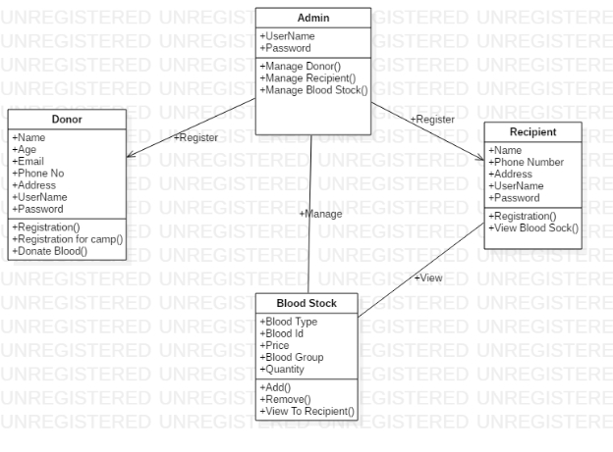

3.3 Activity Diagram:

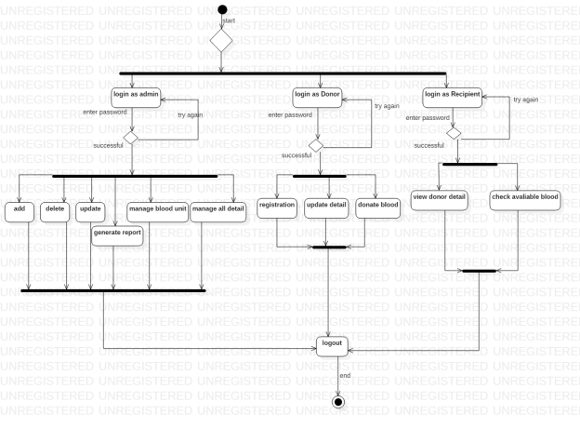

3.4 Sequence Diagram:

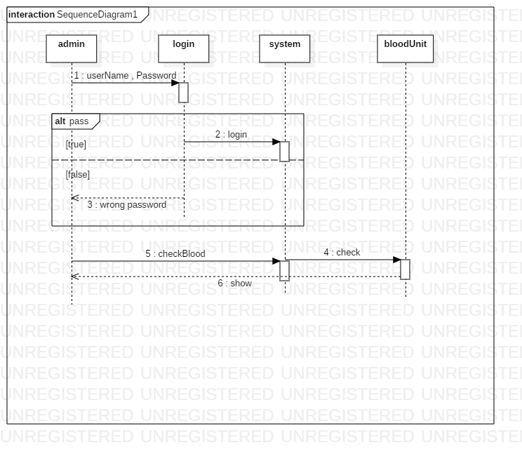

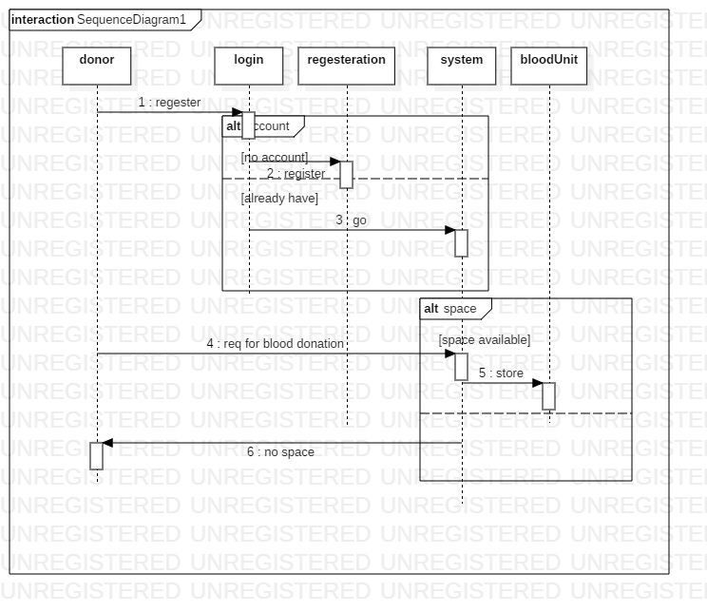

**4 User Interface:**

**Admin**

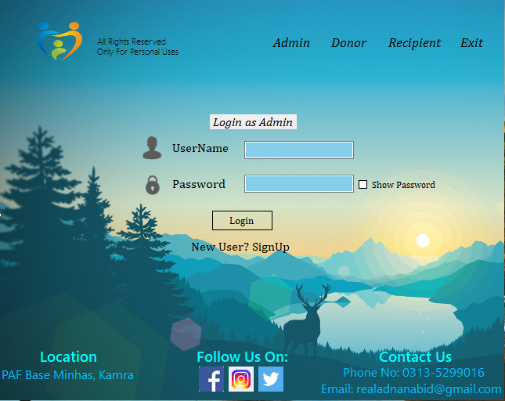

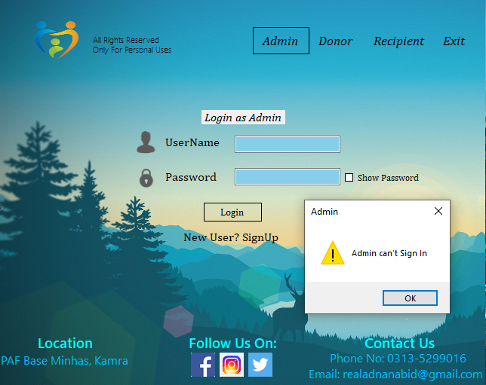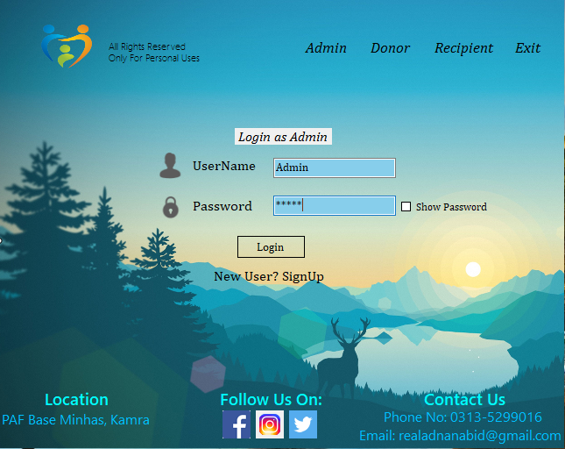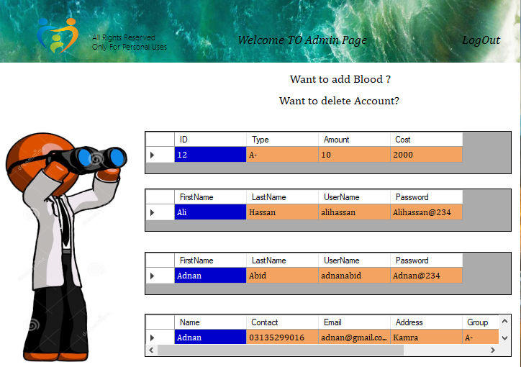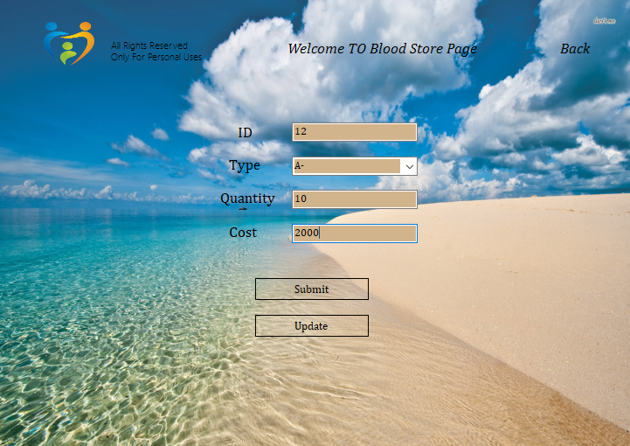

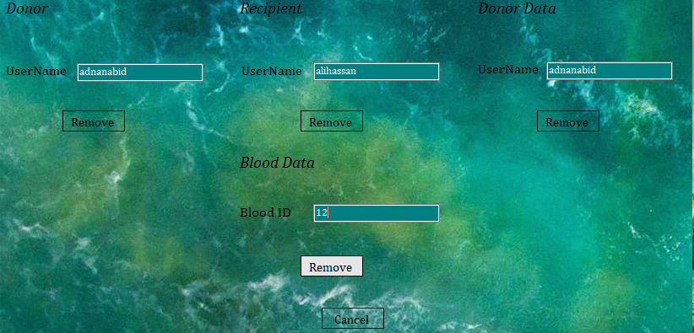

**Donor**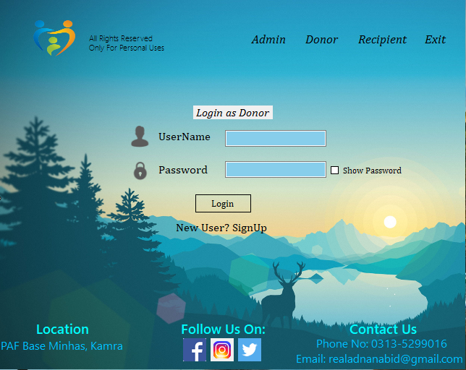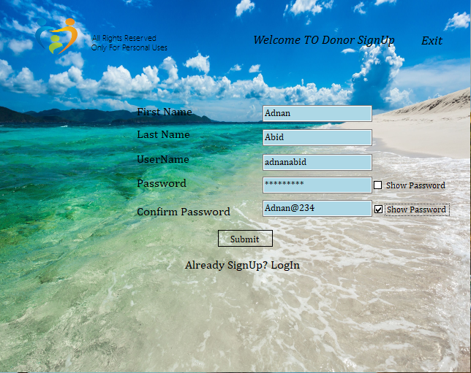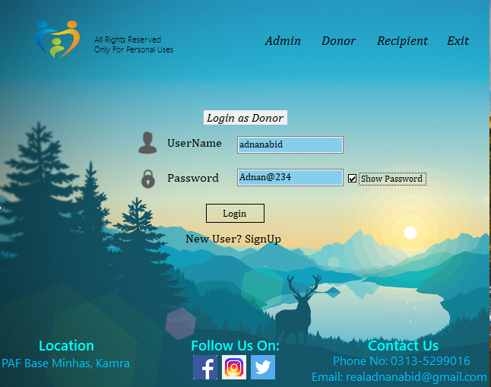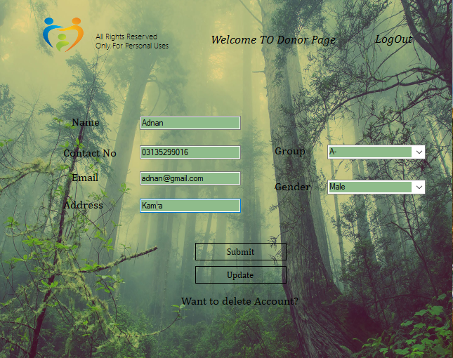

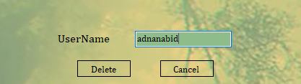

**Recipient**

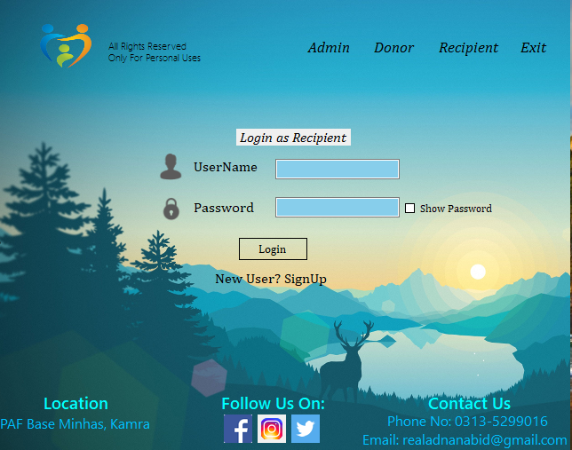

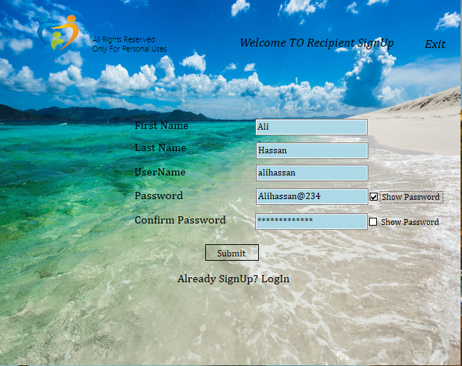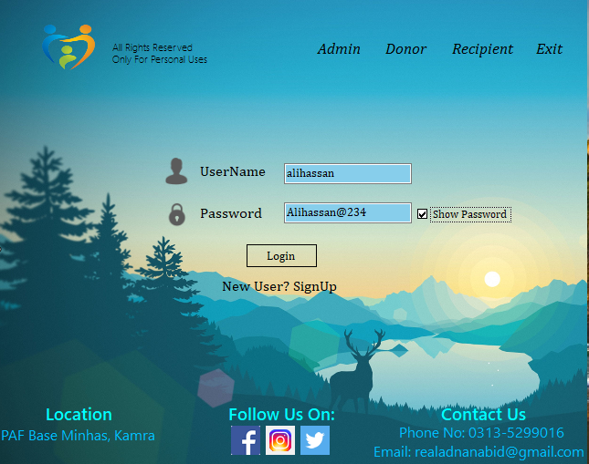

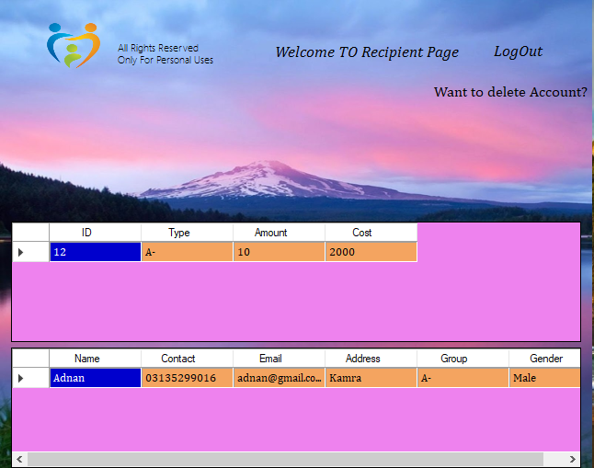

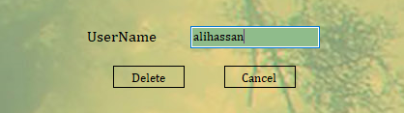

**Database**

